Q4 : Startup MongoDB database.

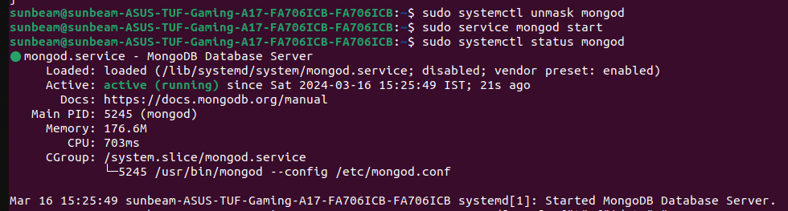
Q5 : Connect to MongoDB database through the MongoDB shell command line interface

Q6 : View list of available databases

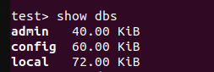

Q7 : Create a new database named CDAC and connect to it

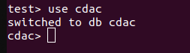

Q8 : View list of available collections in CDAC database

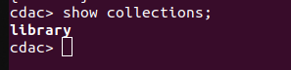
Q9 : Create a new collection by the name LIBRARY

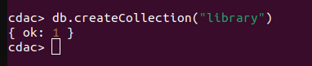

Q10 : Insert the following document in the LIBRARY collection

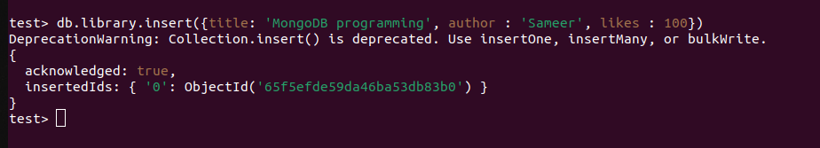

Q11 : View the recently inserted document and note the ID_FIELD
ID : 65f57777c55874cf89db83b1

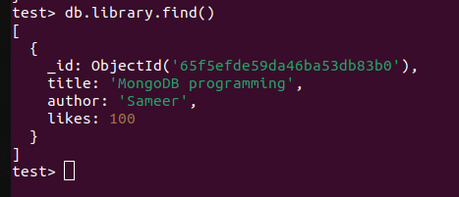

Q12 : Insert another document in the LIBRARY collection

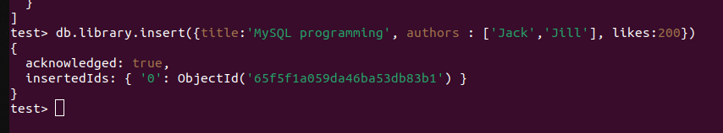

Q13 : View the inserted documents

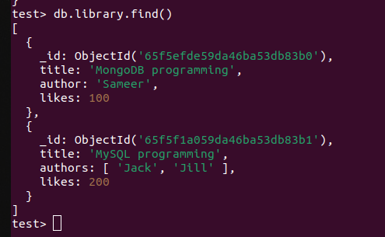
Q14 : View only the first inserted documents

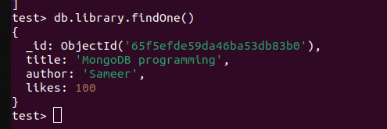
Q15 : View the documents using the pretty() method

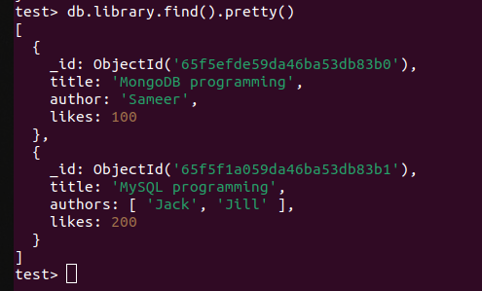

Q16 : Update the document where author name Rushikesh and change it to Rushikesh Mahajan

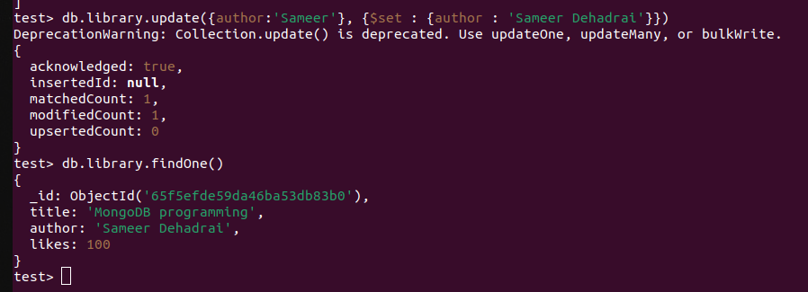
Q17 : Delete all documents that have 100 likes
Q18 : Drop the LIBRARY collection

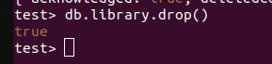

Q19 : Drop the CDAC database

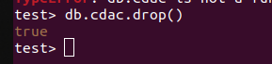

Q20 : Exit from MongoDB shell

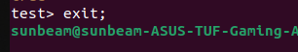

Q21 : Stop MongoDB server

